**ANNUAL REPORT FROM COUNTY COUNCILLOR**

**TO**

**ALL PARISH COUNCILS**

**IN PETERSFIELD HANGERS**

**3 MARCH 2025**

1. The Hampshire Pledge

The Hampshire Cabinet have developed a “Hampshire Pledge” which we are launching this month. I would like to share the pledge with you – see below. The intention is to set out what people can expect from the County Council whilst also encouraging people to take pride and interest in their local community and in their own health and wellbeing. I hope you agree that this is a worthwhile initiative, I would welcome any feedback.

1. Highways Update

Despite another wet winter with unprecedented rainfall and several severe storms, Hampshire Highways have kept our road network in relatively good condition. We have not seen an overload of defects as happened two years ago. Over 1,000 fallen trees were cleared from roads overnight during storms. I appreciate that Parish Councils have had to show patience at times. But the roads are noticeably in a much worse state in West Sussex! Now that we have some drier weather I am confident that the Highways teams will quickly address all the outstanding issues.

Despite the funding challenges at HCC, I am pleased to say that an extra £7.5m funding went into Highways in the 2024/25 year. This funding made a difference because it meant that more crews were on standby and more resources were available to those crews. For the coming year, starting on 1 April, national funding for Hampshire Highways has increased by an extra £14,099,000. This puts us in a strong position for the next 12 months. In addition, £4.25m of HS2 money from the Network North scheme is being used each year to resurface 19 main routes across Hampshire, including the A272 through Stroud, over the two-year period 2024-26.

The Highways Engineers have a difficult job and I think they deserve huge credit for their professionalism. The greatest difficulty this year has been surface flooding. The high water table and the heavy rain have caused many localised problems. The reality is that the flooding teams are stretched. The best advice I can give is to keep [reporting flood problems on the website here](https://www.hants.gov.uk/transport/highways/report-a-problem/flooding) and also make use of the tips in the [Community Toolkit](https://www.hants.gov.uk/landplanningandenvironment/environment/flooding/managing-risk) on flooding.

1. Hampshire Forest Partnership

The Hampshire Forest Partnership which I launched in 2022 continues to go from strength to strength. Over 60,000 trees have now been planted. The winter planting season is just now ending, which makes this a great time to start planning for the next planting season in November 2025 – February 2026.

Free trees and free advice are still available from the HFP team. It would be great to get some more mini-forest projects underway following the success of the mini-forest in Sheet, next to the Adhurst allotments. If you would like to discuss a potential site please drop an email to: [treeplanting@hants.gov.uk](mailto:treeplanting@hants.gov.uk)

1. Standing up for Hampshire

Over the last year, HCC has taken a prominent role in standing up for Hampshire. In our view, Hampshire has been disproportionately affected by Government decisions which were not part of the Labour manifesto.

We have pushed back on the family farms tax which will affect several hundred farms in Hampshire. Hampshire is a county which depends on its family farms for our food, economy, landscape and environment. So in my view it is right that we are taking this stand. We have also written to the Government to protest about the scrapping of winter fuel payments to pensioners. This policy decision will affect Hampshire more than other counties due to our demographics. Finally, we have also led the protests against the Chancellor’s increase to Employers National Insurance. This will push up costs for the Council and for care homes by tens of millions, and these costs will ultimately be borne by local taxpayers. We hope that the Chancellor reverses course in her March budget.

1. Year of Health and Wellbeing

In September 2024 HCC launched a Year of Health and Wellbeing. By coincidence I also took on the role of Executive Member for Health and Wellbeing that month. This initiative comes under the auspices of the Hampshire 2050 Partnership: a partnership of local government, business, universities and the voluntary sector. The aim is to integrate health and wellbeing into our workplace policies and day-to-day working practices. It is an opportunity for cross-sectoral working focussing on the health and wellbeing of Hampshire’s residents. The three core priorities of focus during the Year of Health and Wellbeing are:

* Physical activity
* Mental wellbeing
* Childhood obesity

I see this as crucial to improving our quality of life in Hampshire. A healthier workforce will also be good for the local economy and will relieve pressure on the NHS. The priorities also intersect with the partnership’s other key strategic drivers including impact on economic prosperity, climate change and the natural environment. A toolkit is available at this link:

<https://www.hants.gov.uk/aboutthecouncil/haveyoursay/visionforhampshire2050/health-and-wellbeing/health-and-wellbeing-toolkit>

1. Byways Open to All Traffic (BOATs)

Following years of sustained lobbying by Councillors across East Hampshire, we are getting closer to a new HCC policy on management of our BOATs which will reduce conflict, damage and nuisance caused by vehicles.

I am optimistic that the new policy will be approved by the Summer. In future, the intention is that the County Council will seek to maintain its unsurfaced road network as natural unsurfaced corridors for all users to use and enjoy; it will not surface routes to cater for vehicle use. Instead, the County Council will seek to sustainably preserve the physical character of the route and may seek to reduce levels of usage to allow for fluctuations in the condition of the route.

The County Council may then take action to limit or prevent access by motor vehicles, to prevent damage, to ensure that non-motorised users are able to use the routes, and to protect and preserve the nature and character of the route. A new Byways Operating Procedure will give greater weight to environmental designations. Seasonal Traffic Regulation Orders (TRO) will be applied to a wider range of byways thanks to a new High Amber category. Signage and barriers will continue to be implemented and further TRO measures may also be considered. I feel that this is definitely a step in the right direction which will benefit local communities and the environment.

1. Beavers return to the South Downs after 600 years

In December 2024 a pair of Beavers named Willow and Wilson were introduced to the River Meon near Petersfield, having been transported from Scotland by the Beaver Trust.

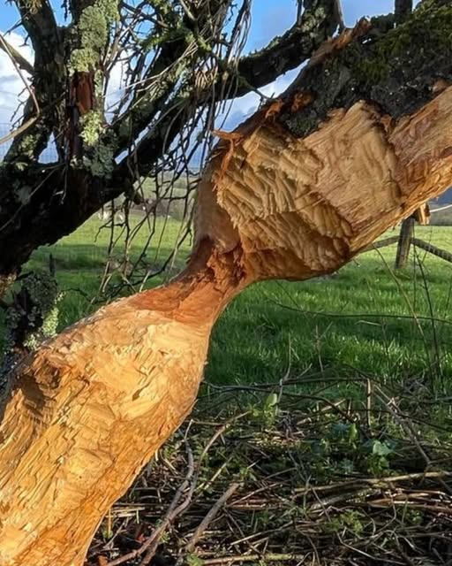

The semi-aquatic mammals, which were hunted to extinction in the 16th Century, create wetlands and wildlife habitats. The impact they have on their new environment will be tracked by a team of academics from Southampton University. They have been busy beavers and have almost chewed their way through this crab apple tree! You can follow the adventures of the Beavers on Facebook at <https://www.facebook.com/Meonsidemeats/>

1. Government consultation on Devolution underway

Hampshire residents are invited to have their say on devolution proposals for Hampshire and the Solent region in a Government consultation which is ongoing. The consultation runs until 13 April 2025 and I would encourage everyone to respond. The consultation can be found here: [Hampshire and the Solent devolution consultation - GOV.UK](https://www.gov.uk/government/consultations/hampshire-and-the-solent-devolution/hampshire-and-the-solent-devolution-consultation)  
  
Commenting, Leader of Hampshire County Council Leader, Councillor Nick Adams-King said: “Devolution represents the biggest change to local government in a generation and as such, it is really important that local people across the wider Hampshire area have the opportunity to comment on the proposals. Collectively, alongside our three partners, joining the Government's Devolution Priority Programme is a fantastic opportunity for Hampshire to self-determine and shape devolution proposals in the best interests of our residents and communities.”  
  
HCC has also developed its own web pages about devolution, including Q&As, which can be found at [www.hants.gov.uk/devolution](https://www.hants.gov.uk/aboutthecouncil/governmentinhampshire/devolution).  

1. Summary of grants awarded by me

For transparency, every year I publish my list of grants awarded. Here is the list for the year ending March 2025.

|  |  |  |
| --- | --- | --- |
| **Applicant** | **Project** | **Grant (£)** |
| Ropley Parish Council | Installing Kissing Gates to improve access to Ropley footpaths | 800 |
| Newman Collard Playing Fields Trust | Bulb and wildflower Project | 800 |
| Greatham Parish Council | Community Minibus – purchase of 17 seater to support primary school and the village. | 900 |
| Steep War Memorial Club | Potted flowers to improve look of the Village Hall | 250 |
| Home-Start Butser | Nurture Parenting Puzzle Training | 800 |
| Froxfield & Privett Parish Council | Parish Verge Cutting | 800 |
| Steep and Stroud Newsletter | Keeping communities informed and engaged | 800 |
| Steep Film Society | Installation of Induction Loop, PA system and professional tuning | 500 |
| Petersfield Shakespeare Festival | Production of Twelfth Night | 750 |
| Petersfield Twinning Association | Exchange Visits from Warendorf and Barentin | 800 |
| Sheet Parish Council | Speed Reduction measures | 800 |
|  | **TOTAL** | **8,000** |

Normally, this year’s grant round would reopen on 1 June 2025. But the delay to the elections and the budget gap at HCC have complicated matters for this coming year. No decisions have yet been taken on the availability or not of County Councillor grant pots for the year 2025-26. I am expecting that the decision will be taken in September 2025. I am afraid that this means that I will not be able to consider any new grant requests until September.

**RUSSELL OPPENHEIMER**

**County Councillor for Petersfield Hangers**